How do I?

Install Pluckeye
If you use more than one browser you must install Pluckeye on all browsers. Installing Pluckeye on one browser, does not also install it on all other browsers you use.

Firefox and Chrome
- Download and save the installation file.
- Close Firefox and Chrome.
- Run installation file.
- When prompted from the browser, enable the Pluckeye extension.
Congratulations. You’ve taken the first step to self-control. Pluckeye has now blocked images on all sites.
Need to see images on a site or page that you know is safe? Allow the site or page display content.

Browsers other than Chrome and Firefox
! | Warning: Pluckeye does not work with Internet Explorer or Edge. Installing Pluckeye on Internet Explorer or Edge results in blocking all sites, without the ability to enable any sites.
- **Do we have a list of other browsers that Pluckeye works with? If so should list them here or add some disclaimer about installing**

Android
**Need content**

Mac OS
**Need content**

Subscribe to Pluckeye
Has Pluckeye changed your life and freed you from the bondage of looking at sites you shouldn’t view? Want to show your gratitude? Great. You can subscribe to Pluckeye for a very reasonable monthly amount that is based on your income. If you are unable to pay the small monthly subscription rate, you have the option to complete the Pluckeye survey.
After you have used Pluckeye at no cost for **how long?** Pluckeye reminds you to consider subscribing. You are notified that you have a Pluckeye reminder by the icon that appears on the Pluckeye icon. The remunerate option is highlighted.
From the Pluckeye menu, click remunerate.
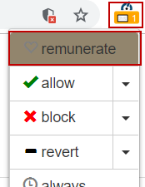
The Pluckeye renumeration page opens in a separate browser window and provides the following options.
Option | Choose this option if …
Subscribe | You want to calculate your subscription rate based on your income and subscribe to Pluckeye
Take a Survey | You cannot afford to subscribe to Pluckeye and are willing to provide feedback by taking a short survey
Free Lunch | You cannot afford to subscribe to Pluckeye and are unwilling to complete the short survey
- Click Subscribe.
Pluckeye displays the subscription calculator.
- From the subscription calculator, select the amount that represents your annual income.
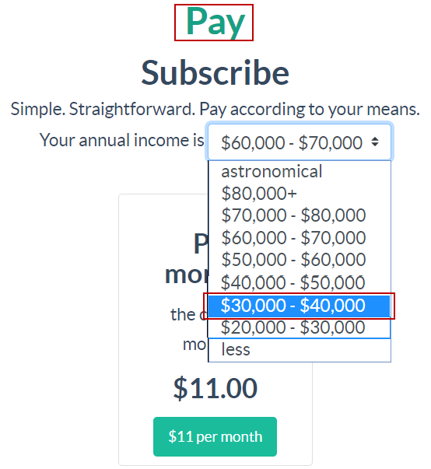
Pluckeye displays the monthly subscription rate based on your income.
Note: When your income is $20,000 - $30,000 or less, the subscription rate is so low that it is a quarterly rate.
- Select the subscription option.
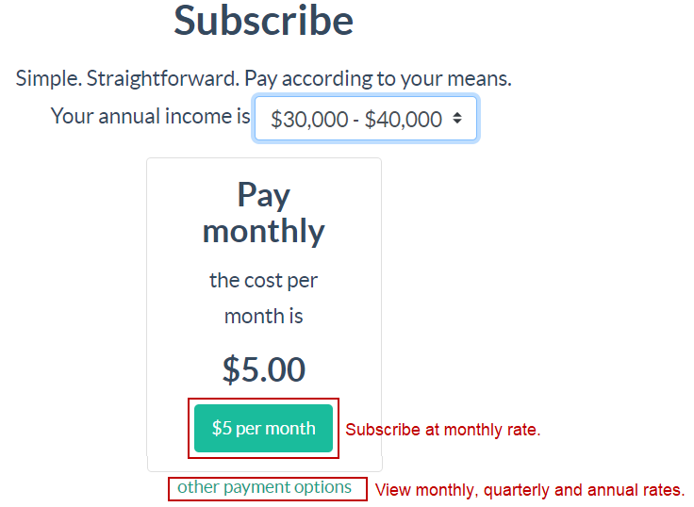
  - To subscribe at the low monthly rate, click the monthly rate button.
  - To view monthly, quarterly and annual rates:
    - Click other payment options.
Pluckeye displays the monthly, quarterly, and annual options.
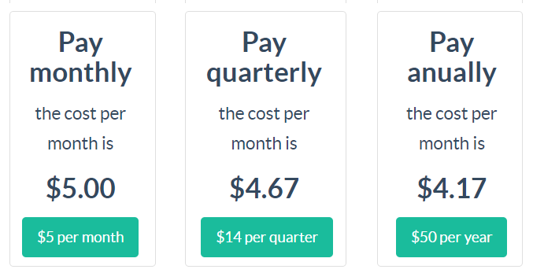
    - Click the button that corresponds to the desired subscription option.
When you click a subscription option, Pluckeye displays the payment screen.
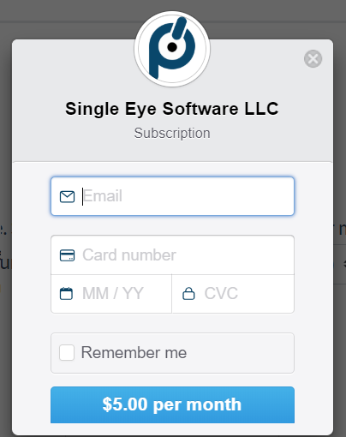
- Provide the required information and click the payment amount button.
Pluckeye displays a confirmation message and sends an email to the email address you provided. Pluckeye will charge your credit card in accordance with the option you selected (monthly, quarterly, or annual).

Update Pluckeye to the newest version
When a new version of Pluckeye is available, Pluckeye lets you know buy adding the reminder icon to the Pluckeye icon, and by adding the Update option to the Pluckeye menu. When you position the mouse over the update option, Pluckeye displays the newest version number.
If you have installed Pluckeye on multiple browsers, you must update Pluckeye on each browser.
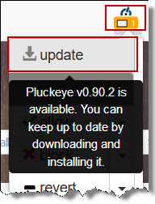
- From the Pluckeye menu click the update option.
Pluckeye displays the release notes in a new browser window.
- From the release notes, click the button for the most current release.
Pluckeye displays the user agreement.
- Agree to the terms of the user agreement.
Pluckeye installs the most recent version and displays a confirmation page in a new browser window.
When you update Pluckeye to the newest version, Pluckeye keeps your settings, including pages and sites that you enabled and the delay time.

Allow a site or page to display content
By default, Pluckeye blocks graphic content on all sites. Depending on the browser, you will see either a blank page or a message stating that the site has been blocked. The allow option allows you to display graphic content on an entire site or on one or more selected pages within the site.
The site or page you allow is allowed for all browsers on which you have installed Pluckeye.
! | Warning: This option allows the site or page to display all content. Take time to think about the site to ensure that all content on this site or page is **safe for you** before allowing the site or page.

- Navigate to the site or page that you want to allow.
- From the Pluckeye menu click the Pluckeye click the allow dropdown.
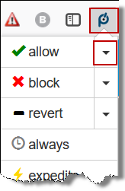
Pluckeye displays the list of site and page options. The list displays all pages from the site’s home page to the current page.
- From the list, select:
- The home page to enable all pages on the site
- The pages you want to allow
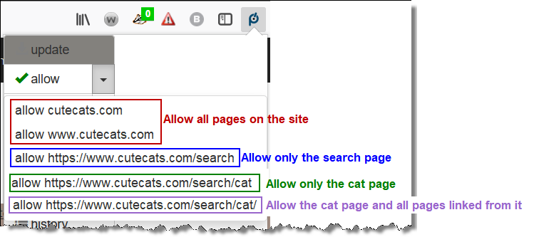
To give you time to carefully consider allowing the site or page, Pluckeye waits for the delay period before allowing the site or page. Use this time wisely to be sure you are making a good choice. How do I know how long the delay is?
Did you decide that the decision to allow the site or page is not a good choice? Click here to learn how to stop the pending allow before it takes effect.
After the delay period has expired, reload the page. Pluckeye displays the site or page with all graphics.
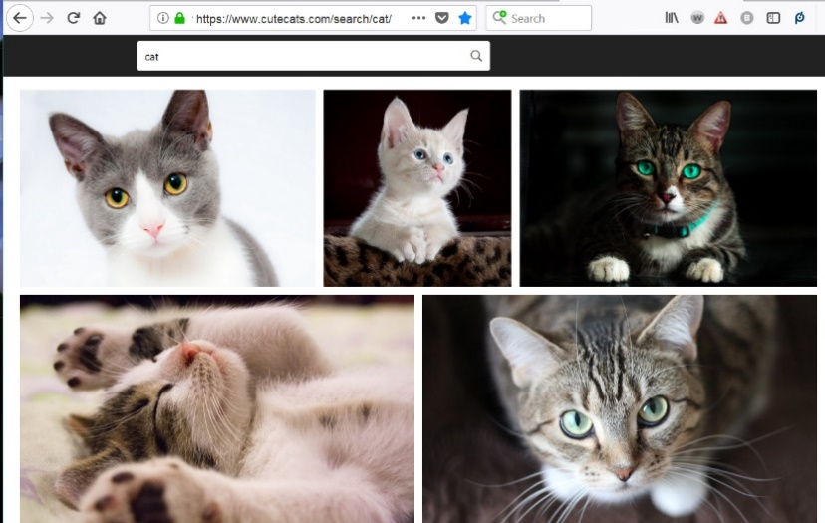
By default, Pluckeye permanently allows content on the site or page. Want the change to be temporary?
Click here to learn how.

Block a site or page from displaying content
Oops. Did you allow a site or page that you shouldn’t have allowed? By default, Pluckeye blocks graphic content for all sites and pages. However, if you allowed a site or page that you should not have allowed, you can block that site or page.
Complete the following steps to manually block a site or page that you previously allowed.
Click here to learn how to automatically revert to the previous settings for the site.
- Navigate to the site or page that you want to allow.
- From the Pluckeye menu click the block dropdown.
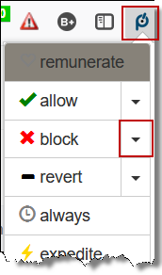
Pluckeye displays the list of site and page options. The list displays all pages from the site’s home page to the current page.
- From the list, select:
- The home page to block all pages on the site
- The specific pages you want to block
! | Tip: Content might appear on multiple pages on the site; for example, a photo gallery appears on one page with links to pictures in the gallery that display on a separate page. Be sure to block the first page in the site hierarchy on which content you want to block appears and all pages it links to.

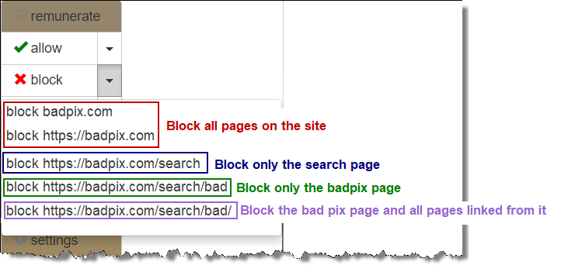
- If you are using Firefox, close the browser. If you do not close the browser, Firefox displays the cached version of the page you have blocked.
After the time set for the delay, Pluckeye blocks the site or page.
If during the delay time you determine that the site should not be allowed, you can stop the pending allow action. Click here to learn how to abort a pending allow or block action.
When you try to access a blocked site or page, what appears depends on what browser you are using.
Browser | Home Page | Page Other Than Home Page
Chrome | Displays a blank page. | Does not display the page; remains on the current page.
Firefox | Displays a message stating that the site is blocked. | Displays a message stating that the site is blocked.

The site or page you block is blocked for all browsers on which you have installed Pluckeye.
Did you decide that the decision to block the site or page is not a good choice? Click here to learn how to stop the pending block before it takes effect.

Undo a change and revert to the previous setting
Oops. Did you allow a site or page you should not have allowed, or did you block a page that is safe? You can easily revert to the previous settings for the site or page.
If you want to change the site or page settings to something other than the previous setting, manually allow or manually block the site or page.
- Navigate to the site or page whose setting you want to revert.
- From the Pluckeye menu, click revert dropdown.
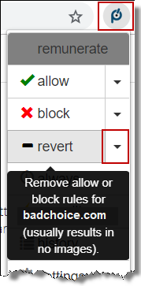
Pluckeye displays the list of site and page options. The list displays all pages from the site’s home page to the current page.
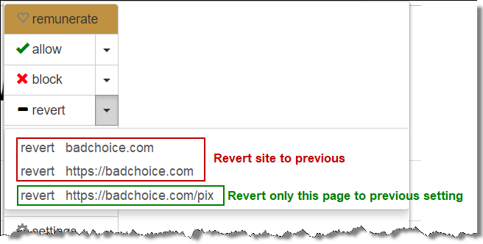
- From the list, select:
- The home page to revert the setting for all pages on the site
- The pages whose settings you want to revert
- If you are using Firefox, close the browser. If you do not close the browser, Firefox displays the cached version of the page.

Make a change temporary
By default, changes to the allow and block settings are permanent until you change them. However, the always option enables you to make an allow or block change temporary by specifying the length of time the change should be in effect. After the specified time expires, the allow or block change reverts to the default duration time of always, which makes changes permanent.
! | Important: The change duration setting applies only to the next allow or block change you make or until you close the Pluckeye menu. If you close the Pluckeye menu before allowing or blocking a site or page, Pluckeye will reset the change duration to the default value of always.

- From the Pluckeye menu, click always.
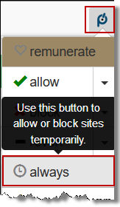
Pluckeye displays the list of change duration options.
- From the list of duration options, click the desired duration.
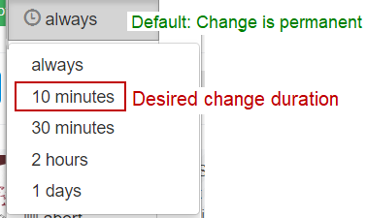
Pluckeye displays the new change duration in the Pluckeye menu. The change duration time applies only to the next change you make and then returns to the default value of always.
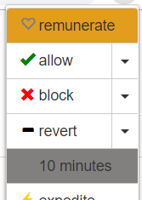
- Without closing the Pluckeye menu, make the allow or block change.
Click here to learn how to allow a site or page.
Click here to learn how to block a site or page.
! | Important: If you close the Pluckeye menu before making the allow or block change, Pluckeye resets the change duration to always.

The allow or block will be effective after the expiration of the delay time and will remain in effect only until the change duration time you specified expires. After that time, the setting reverts to its previous value; an allowed site reverts to blocked, or a blocked site reverts to allowed.
Click here to learn how to view the delay time.
Click here to learn how to change the delay time.

**??What is expedite?**

View my browsing history
Pluckeye enables you to view a log that lists all the content you have accessed during the current browser session and to identify what content has been allowed and what content is blocked. When you close the browser, the Pluckeye history is **erased**.
- From the Pluckeye menu, click history.
Pluckeye displays the list of all URLs you have visited during the current browser session. The history includes images.
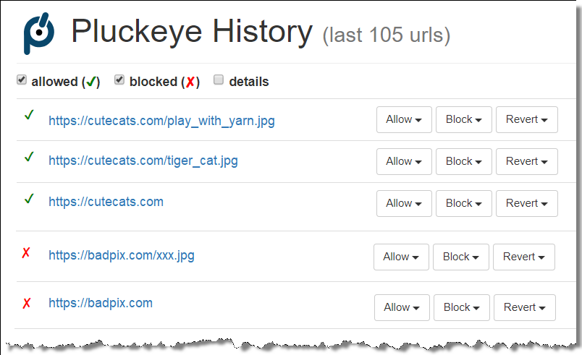
A green check mark appears before allowed sites and content; a red x appears before blocked sites and content.
- Optionally use the Allow, Block, and Revert options to modify the site or page settings.
These options work in the same way the corresponding options on the Pluckeye browser menu work.
Click here to learn how to allow a site or page.
Click here to learn how to block a site or page.
Click here to learn how to revert the site or page setting to its previous setting.

Change the delay time
The delay time is an important feature of Pluckeye. It determines how long Pluckeye waits before applying changes to all Pluckeye settings, including allowing a site or page. This allows time for you to consider whether or not a site or page you have allowed is a safe site.
The default delay time is 0 (zero) seconds. We strongly urge you to change the delay time to one that allows you to carefully consider the change to allow a site or page.
Click here to learn how to view the current delay setting.
- From the Pluckeye menu, click settings.
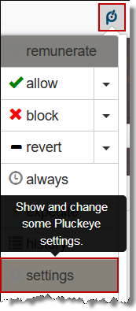
Pluckeye displays your current settings in the browser. This example shows the default setting. The Delay setting consists of the time duration and the time unit.
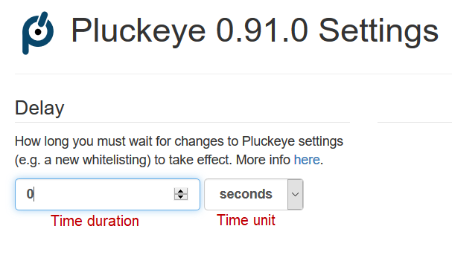
- From the time duration box enter the desired duration.
- From the time unit list, select the desired time unit.
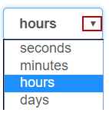
- Click the Apply button at the center bottom of the settings screen.
After the previous delay time expires, Pluckeye updates the delay setting.

Stop a craving to view **bad** sites
Craving to view content that you know you should avoid? The crave option provides an extensive list of suggestions for healthy activities you can do to avoid giving in to that craving.
- From the Pluckeye menu, click crave.
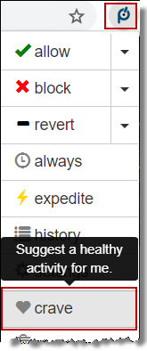
Pluckeye opens a new browser window.
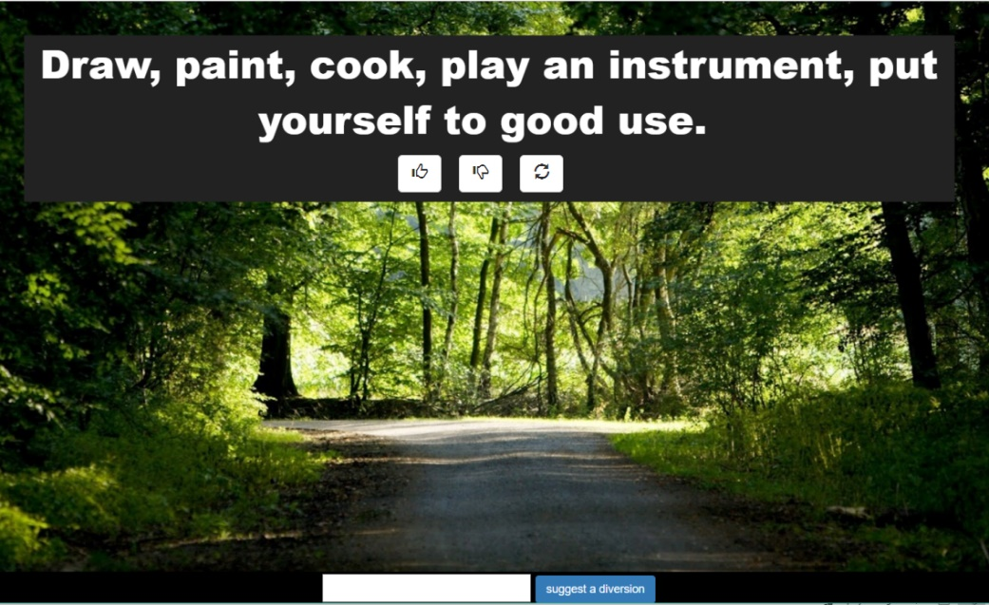
- If the displayed suggested doesn’t work for you, click the **need word to describe the button** to view another suggestion. Keep viewing suggestions until you find one that works for you.
- Follow the suggestion and avoid giving in to the craving.
- If the suggestion worked, give it a “thumbs up;” if it didn’t work, give it a “thumbs down” and try another suggestion
If the craving is too great and you are tempted to allow a site you should not view, try the lockdown option. Click here to learn about the lockdown option.

Stop a pending change before it takes effect
Did you decide that a pending change was a bad choice? When the delay time has not expired, you can abort the pending change.
- From the Pluckeye menu, click abort.
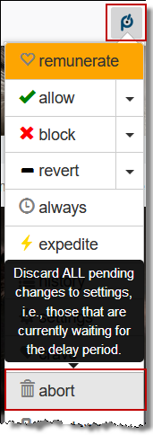
Pluckeye displays a confirmation message.
- Click OK to abort the pending change.
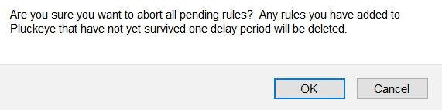
To continue with the pending change, click Cancel.

Temporarily prevent Pluckeye from making any changes
If the craving is too great and you are tempted to allow a site you should not view, lockdown prevents Pluckeye from allowing any sites or pages for 24 hours. This ensures that you cannot give in to the temptation and allow a site or content that you know you should not view.
- From the Pluckeye menu, click lockdown.
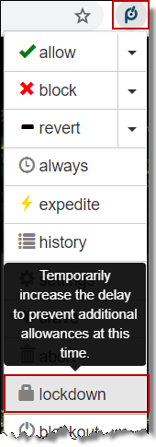
Pluckeye displays a confirmation message.
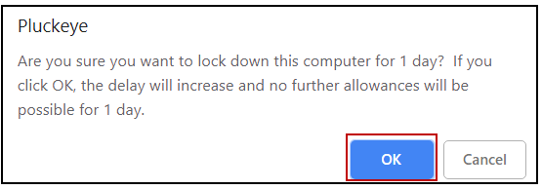
- Click OK to lockdown allowing any sites or pages for 1 day.
Need a suggestion about a healthy activity to help overcome the temptation to view **bad** content? Click here to learn how view suggestions for a healthy activity.

Temporarily prevent all internet access
The craving and temptation just too much? Want to ensure you won’t look at content that you will regret viewing? If the suggestions in the crave option didn’t help, you can block all internet access for the time set as the delay time.
! | Warning: This option cuts off all internet access during the delay time.

Click here to learn how to view the delay time.
Click here to learn how to change the delay time.
- From the Pluckeye menu, click blackout.
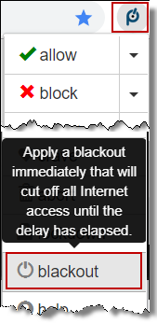
Pluckeye displays a confirmation message.
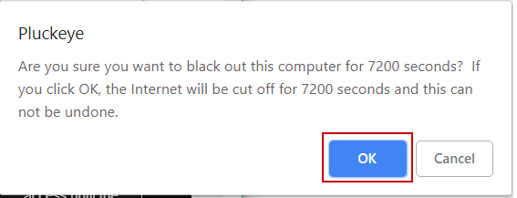
- Click OK to confirm that you want to block all internet access for the delay time.

What does it do?

Remunerate
When you have not yet subscribed to Pluckeye, the remunerate option appears on the Pluckeye menu. Pluckeye subscription rates are extremely affordable and based on your annual income. The remunerate option provides a subscription calculator that enables you to calculate your Pluckeye subscription rate based on your annual income, as well as to subscribe to Pluckeye.
If you are unable to afford the Pluckeye subscription, the remunerate option also provides an option to complete a short survey as a way to show your appreciation for Pluckeye and to provide valuable information **how is it used**
Click here to learn how to subscribe to Pluckeye.

Update
When a new version of Pluckeye is available, the update option appears on the Pluckeye menu. Updating Pluckeye ensures that you are using the most current version and have access to all the latest improvements.
! | Important: If you use multiple browsers, be sure to update Pluckeye from all browsers. Updating Pluckeye from on browser does not update it on other browsers.
Click here to learn how to update Pluckeye.

Allow
The allow option enables you to view images on the current site or page. From any page on a site, Pluckeye enables you to allow the entire site, or only specific pages on the site.
! | Warning: This option allows the site or page to display all content. Take time to think about the site to ensure that all content on this site or page is **safe** before allowing the site or page.
Click here to learn how to allow a site or page.

Block
The block option enables you to block images on the current site or page when you have previously allowed it. Pluckeye enables you to blcok the entire site, or only specific pages on the site.
Click here to learn how to block a site or page.

Revert
The revert option is like “undo.” It reverses the last change you made are reverts to the previous setting. For example, if you allowed a site and realize it is not a safe site, the revert option will undo the allow and return to the previous blocked setting.
Click here to learn how to undo a change and revert to the previous setting.

Always
By default, changes to the allow and block settings are permanent until you change them. However, the always option enables you to make an allow or block change temporary by specifying the length of time the change should be in effect. After the specified time expires, the allow or block change reverts to the default duration time of always, which makes changes permanent.
Click here to learn how to make an allow or block setting temporary.

Expedite
**Need content**

History
Use the history option to view a log that lists all the content you have accessed during the current browser session. The list identifies what content has been allowed and what content is blocked. It also provides the ability to change the allow or block setting.
Click here to learn how to view the browsing history for the current browser session.

Settings
Pluckeye settings includes the delay time that determines how long Pluckeye waits to implement an allow change. The delay is an important feature of Pluckeye, because it ensures that you are able to take time to carefully consider the decision to allow a site.
The default delay time is 0 (zero) seconds. We strongly urge you to change the delay time to one that allows you to carefully consider the change to allow a site or page. The delay time you set appears at the bottom of the Pluckeye menu.
**Do you want me to include anything about installation level?**
Click here to learn how to set the delay time.

Crave
Sometimes the craving is just too much. When that happens, use the crave option to view healthy activities that can serve as a diversion and provide time to allow the craving to pass. Not only can you view suggestions from other Pluckeye users, but you can contribute suggestion of your own.
Click here to learn how to use the crave option.

Abort

Lockdown

Blackout

FAQs

What does Pluckeye cost?

Can I donate to Pluckeye?

What operating systems support Pluckeye?

What browsers support Pluckeye?

Can I allow only some pages on a site?

Can I block a site or page that I allowed?
Yes, you can block a site or page that you have allowed.
Want to block a site or page? Click here for instructions.

What does the delay do?
The Pluckeye delay is the most important Pluckeye setting. It determines how long Pluckeye waits to allow or block a site or page. The delay is important when you allow a site or page, because it gives you time to consider the choice before it takes effect. You should set the delay to a time that is long enough to allow you to very carefully consider and choice.
If, during the delay time, you determine that the site should not be allowed, you can cancel the allow selection.
Want to change the delay time? Click here for instructions.

Can I temporarily allow a site or page?

Can I stop Pluckeye from allowing a site during the delay time?

Can I see what pages I have visited in the current browser session?

How does Pluckeye work?

How is Pluckeye different from other filters?

Can I change the delay time?

How can I tell what the delay time is?
The delay time displays at the bottom of the Pluckeye menu.
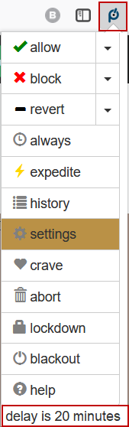
Want to change the delay time? Click here for instructions.

How do I update Pluckeye to the most current version?

How do I know when a new version of Pluckeye is available?

